Homework PACKET 6

iDAHO pUBLIC dRIVER eDUCATION

Intersections & Turnabouts

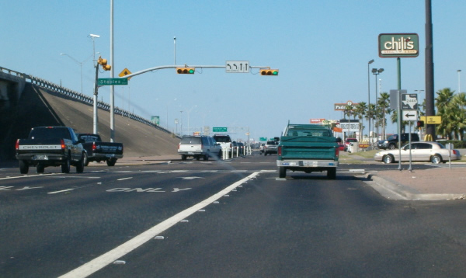
If you are the driver in the scenario above (this view is out your windshield), if you want to turn right are you able to do so at this light? Can you turn left in this lane? What state are you driving in? If you are traveling at 35 mph and plan to continue straight does it look like you will make it through this green light? What do you predict the silver car will do after the green truck clears the intersection? These are the kinds of questions (other than “what state are you are driving in?”) that you should be asking at every intersection.

The Point of No Return

Every intersection has a point at which if you don’t apply the brakes NOW - you will not be able to stop safely if the light turns yellow or red and you need to stop. This “point of no return” changes from intersection to intersection depending on the speed limit, your vehicle’s weight, the condition of your brakes and tires, and how long that particular light stays green. The best strategy for handling the point of no return is to give every intersection your full attention – especially at the point of no return where you have to decide whether to proceed or stop.

When the light turns green and you are starting from a stopped position at an intersection, always look LEFT-RIGHT-LEFT before entering the intersection. (Can you think of why this is important?)

INTERSECTIONS

The chances of a crash are higher at an intersection than any other location. Why? Because it is here that vehicles cross each other’s’ paths with a variety of traffic control signs and devices and at a variety of speeds.

The solution is simple: use IPDE and Zone Control to carefully navigate every intersection – always knowing who has the right of way – and never assuming you have the right of way even if you legally do. Expect other vehicles to run the red light. Expect others to be driving while distracted – be it texting, talking, shaving, or interacting with the sound or navigation system. If you drive defensively like this, watching out for others, you are on your way to a long career as a safe driver!

When approaching an intersection, IDENTIFY any restrictions to your front left, front, and front right zones. When you are 4-6 seconds from the intersection, widen your visual search pattern to better see cross traffic and pedestrians. PREDICT what others might do – and what the traffic light (if there is one) will do. DECIDE what you need to do to navigate the intersection safely and if there are no changes to your POT or LOS, EXECUTE your travel through the intersection.

Just before you enter an intersection check your rearview mirror to see if there is a vehicle following closely behind you – especially if the light is turning yellow or red. Vehicles may try to “push” you through the intersection and if you decide to stop because the light is yellow (or red) a tailgating vehicle may hit you from behind.

HOMEWORK PACKET 6

Idaho public driver education

Turns at a Red Light

Idaho law allows you to turn right at a red light after stopping and yielding to cross traffic. You may also turn left at a red light after stopping and yielding to cross traffic AND if turning onto a one-way street.

Railroad Crossings

Railroad crossings also come in controlled and uncontrolled. In heavy traffic areas these crossings may have gates, flashing lights, and even bells to warn drivers of an approaching train. But most railroad crossings in Idaho and other states are in rural areas and there will not be any electronic warnings – maybe a railroad crossing warning sign and crossbuck.
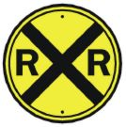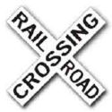
The yellow and black round railroad crossing warning sign is placed 100 feet or less from a railroad crossing and gives a driver time to slow down and yield to train traffic. The white and black crossbuck sign is placed on the right side of the road near the railroad tracks. These signs may or may not list the number of tracks present at this crossing but they are a warning that you will be crossing railroad tracks. Train traffic in America has actually increased over the years and trains can come by any time. It is illegal to cross a railroad crossing if the electronic lights or bells are operating and illegal to drive around a gate, even if the train has already passed.

Trying to beat a train to a railroad crossing is a game that should not be played. A fast-approaching train will appear to be traveling much slower than it actually is.
LOOK-LISTEN-LIVE!
Intersection Controls

Intersections are either uncontrolled (no signs or signals) or controlled (by signs or signals).

Uncontrolled intersections are often in small neighborhoods with slower speed limits and possibly low levels of traffic. However, these intersections can still be very dangerous to drivers and pedestrians. With no signs or signals to tell drivers who has the right of way, what is a driver supposed to do?
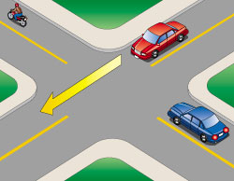
Treat an uncontrolled intersection like a 4-way stop. Sometimes they are referred to as a “4-way yield”. The vehicle that gets there first goes first. If two vehicles get there at the same time the vehicle on the right has the right of way. Vehicles do not have to stop but beware! Drivers of larger vehicles sometimes assume they have the right of way and drivers on the busier road often feel they have the right of way. They don’t. So yield, be cautious, and make sure you are being given the right of way before entering the intersection.

Signs you might see at an intersection include STOP, YIELD, and merge signs. Signals might include traditional red-yellow-green lights, dog house signals with additional lights and/or arrows, protected turns and unprotected turns.

TURNABOUTS
HOMEWORK PACKET 6

Idaho Public Driver Education

TURNABOUTS

When you need to turn around but cannot simply go around the block, a turnabout is the method to use.

The safest is the 2-point turn, in which you temporarily pull into a driveway or side street before changing directions. In the diagram below, the vehicle is driving from the left to the right but realizes he needs to turn around and go back the other way. He signals, sees there is no traffic coming from any direction, turns the corner (step #1), stops, backs up (step #2), then moves back in the direction he came from (step #3).
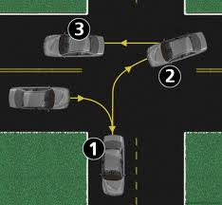

The next safest turnabout is the u-turn. In this maneuver the driver simply signals, slows down, and if there is no traffic, turns sharply until the vehicle has turned 180 degrees and can continue moving in the opposite direction.

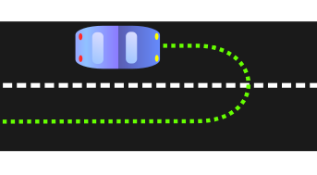
Lastly, if a 2-point turn won’t work because there is no place to pull into and a u-turn won’t work because the street is too narrow, a 3-point turn is the solution.

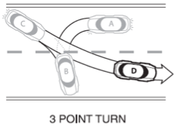
In the diagram above the vehicle has to come to a complete stop IN traffic (step B), which is why it can be dangerous, before backing up (step C, also IN traffic) and continuing on in the opposite direction (step D).

When deciding which of the turnabout maneuvers to use, consider the following:
- Is it legal?
- Is there too much traffic?
- Are driveways or side streets available?
- Will I have to stop IN traffic?
- Will I cause traffic to stop?
- How many traffic lanes will I have to cross?
REVIEW QUESTIONS
HOMEWORK PACKET 6

NAME: _______________________________________ DATE: ____________

DIRECTIONS: Answer the following questions based on what you learned from the homework packet.

- Where are your chances of a crash highest?
- Why would you want to check your rearview mirror at an intersection?
- What is the “point of no return”?
- What is the reason for looking LEFT-RIGHT-LEFT if you are stopped and the light turns green?
- Who goes first at an intersection with no lights or signs?
- If it’s dark and you see a round sign but can’t make out the words, you know it is a _________________________ sign.
- The safest turnabout is the __________________________.

